**Instruction for Camera-Ready Extended Abstract for IWDTF 2023**

Eisuke Tokumitsu1, Shinji Migita2, Tomoyuki Suwa3, Takaaki Miyasako4, and Shun-ichiro Ohmi5

1JAIST, 2AIST, 3Tohoku Univ., 4Murata Manuf., 5Tokyo Tech,

5J2-72, 4259 Nagatsuta, Midori-ku, Yokohama 226-8502, Japan

Email: ohmi@ee.e.titech.ac.jp / Phone: +81-45-924-5481

**1. Introduction**

This set of formatting instructions pertains to the preparation of a camera-ready paper for the IWDTF2023. The extended abstract should clearly and concisely state the originality and specific results of the work.

**2. Experimental Procedure**

The authors are encouraged to submit a 2-page maximum camera-ready abstract written in English in A4-size. Set the top, bottom, and left/right margins to 28 mm, 24 mm, and 15 mm, respectively. The first page should begin with the title, author(s), affiliation(s), contact author’s address and e-mail address. The title should be written in boldface and title case (i.e. all words except articles, prepositions, and conjunctions are capitalized). The main text must be in single-column format with single spacing and full justification. Section headings should be given in boldface.

Do not use fonts smaller than the fonts specified in Table I. As an aid to gauging font size, 1 point is about 0.35 mm. Use a proportional, serif font such as Times or Dutch Roman.

Photographs should have high contrast in black and white. Figure captions should be placed just below their corresponding figures, while table captions should be placed above their corresponding tables

References should be given in a numerical list at the end of the manuscript and cited in the main text by enclosing a reference number in square brackets [1].

**3. Results and Discussion**

Authors are requested to submit the manuscript in pdf file format. Please use standard English fonts such as Times New Roman and Arial, and embed all fonts to ensure that the printed document appears as intended [2,3]. The manuscript should be proofread carefully beforehand in terms of spelling, grammar, and figure image quality [3-5].

**4. Conclusions**

This is a template for the camera-ready paper of IWDTF2023.

**Acknowledgements**

This work was supported by Grant Number xxx, National Science Foundation. (example).

**References**

1. E. Tokumitsu et al., Jpn. J. Appl. Phys. **59**, SPPB03 (2020).
2. S. Migita et al., Jpn. J. Appl. Phys. **57**, 04FD03 (2018).
3. T. Miyasako et al., Jpn. J. Appl. Phys. **57**, 04FD03 (2018).
4. T. Suwa et al., Jpn. J. Appl. Phys. **52**, pp. 031302.1-14 (2013).
5. S. Ohmi et al., Ext. Abst. of IWDTF2021, pp. 49-50 (2021).



Fig. 2 This is a sample figure.

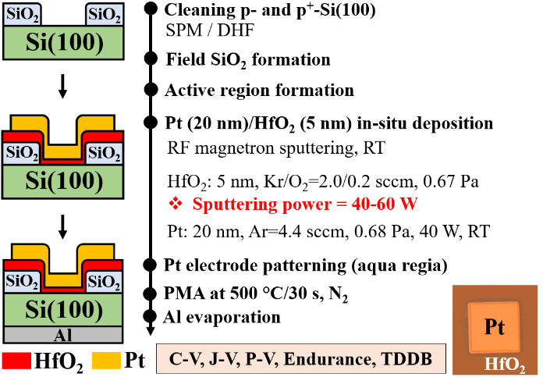

Fig. 1 This is a sample figure. Captions exceeding one line are arranged like this [1].

Table I Font sizes for camera-ready abstract.

|  |  |  |
| --- | --- | --- |
| Font Size | **Bold** | Text |
| 11 |  | Main text, authors’ affiliations, figure captions, table, table captions, references, acknowledgements |
| 11 | **Yes** | Headings, i.e. section title |
| 12 |  | Authors’ names |
| 14 | **Yes** | Paper title |
|  |  |  |